Film Festival Selections
- FEEDBACK Animation Festival: Two festival screenings of “Justin and the Werloobee”: Screening #1: Los Angeles (private screening) and Screening #2: Virtual Festival
- Vancouver Independent Film Festival: “Justin and the Werloobee” was selected for the festival (it did not win an award)

- Golden Harvest Film Festival: “Justin and the Werloobee” was selected for the festival (finalist, honorable mention)
- 4th Dimension Independent Film Festival: “Justin and the Werloobee” has been officially selected for screening at the festival (finalist)
- Montreal Independent Film Festival: “Justin and the Werloobee” was selected for the festival (selected twice) The IMDb qualifying seasonal and annual Montreal Independent Film Festival has turned into one of the most popular visionary festivals on FilmFreeway.
- Fantastic Indie Festival of Los Angeles: “Justin and the Werloobee” was selected for the festival (award winner)
- Imagine Rain Independent Film Awards: “Justin and the Werloobee” was selected for the festival (award winner)
- The 6th Medellín International Film Festival – FestMedallo: “Justin and the Werloobee” was selected for the festival.
- Five Continents International Film Festival: “Justin and the Werloobee” was selected for the festival.
- Rome International Movie Awards: “Justin and the Werloobee” was selected for the festival (award winner)
- Phoenix Shorts: “Justin and the Werloobee” was selected for the festival. Phoenix Shorts is a monthly and yearly online IMDb qualified festival.
- Toronto Independent Film Festival: “Justin and the Werloobee” was selected for the festival. IMDb qualifier's Toronto Independent Festival of CIFT was established in Toronto in 2015.
- Hollywood Gold Awards: “Justin and the Werloobee” was selected for the festival (finalist and award winner)
- Milan Gold Awards: “Justin and the Werloobee” was selected for the festival (finalist and award winner)
- Indie Shorts Awards Cannes Indie Shorts Awards Cannes is an IMDb qualifying event with Public Screenings dedicated to international short films of all genres,
- Hollywood International Golden Age Festival
- Venezia Shorts Italy
- Dreamer’s Short Film Festival (award winner)
- Paris International Short FestivalAn IMDB qualified festvial , Paris International Short Festival is an online-based bi-monthly award festival.
- London Indie Short Festival of 24frames London indie festival of 24frames is a bi-monthly IMDB qualified online short award festival based in London.

- South Film and Arts Academy Festival (award winner)
- Tampa Bay Motion Picture Industry Professionals’ Indie Film Festival
- Dubai Independent Film Festival
- Indian Indie Awards (nominee, Best Animation award)
- Beyond the Curve International Film Festival (finalist, award)
- Hong Kong Indie Film Festival Recognized by IMDB, HIFF is more than just a Film Festival; it is a strong connection among all filmmakers around the world.
- Shepherd’s House International Film Festival (selected, semi-finalist, Award Winner)
- The Oxford International Film Festival
- 2021 Florida Family Film Festival
- European Cinematography Awards (award winner)
- World Distribution Award (award winner)
- ISAFF ISAFF is IMDb-QUALIFYING Event!
- San Francisco Indie Short Festival The IMDb qualified festival of San Francisco Indie Short Festival is happy to welcome filmmakers from all over the world and short films of all genres.
- Berlin Shorts Award Berlin Short Awards is a bi-monthly IMDb qualified online short awards event.
- Vienna Indie Short Film Festival
- Venice Shorts Welcome to the VENICE SHORTS of California, an IMDb qualifying festival dedicated to short filmmaking and independent artists.
- Cairo Indie Short Festival
- International Christian Film & Music Festival (nominee)
- Europa Film Festival 5th Edition (finalist, award winner)
- Kalakari film festival (From your 1 film submission we have donated 5 food packages to poor families) (award winner)
- New York Independent Cinema Awards Welcome to the IMDb qualifying NY Independent Cinema Awards, founded by NY Arts & Cinema Magazine!
- Austin International Art Festival Welcome to the Austin International Art Festival page, an online IMDB qualified awards event.
- LA Independent Film Channel Festival
- Niagara Falls International Short Festival Niagara Falls International Short Festival, an IMDB qualified festival
- Beirut International Children and Family Film Festival
- Alternative Film Festival (finalist, award)
- Couch Film Festival (semi-finalist, best film finalist) COUCHFF is an IMDb-eligible quarterly event committed to highlighting and showcasing the very best films from around the globe.
- Faith and Family Chicago Film Festival
- Philadelphia Independent Film Festival 14 2021The Philadelphia Independent Film Festival is *IMDB certified.
- The Gladiator Film Festival (award winner, selected twice)
- ADIFF-Actor and Director Awards (honorable mention)
- Vegas Shorts
- Sydney Indie Short Festival
- Andromeda Film Festival (award winner)
- Onyko Film Awards (finalist) OFA is an annual IMDb verified festival with monthly awarding and an annual live ceremony with annual winner’s projects screening.
- VIP Fest The Best of 2021
- Toronto Independent Animation Festival
- Cult Movies International Film Festival (finalist, honorable mention) We are an IMDb eligible festival meaning filmmakers will be able to post their nominations and wins on their IMDb profiles.
- Cooper Awards (finalist)
- Nenagh Children’s Film Festival
- Irvine International Film Festival (award winner)
- Ediplay International Film Festival (finalist, award); Featured in Scenema (finalist)
- Indapuram International Short Film Festival (quarter finalist)
- Florida Shorts (semi-finalist) Florida Shorts is a seasonal IMDB qualified festival dedicated to short films from around the world.
- End of Days Film Festival (official nomination in animation category)
- SounDance Film Festival (finalist (drama), finalist (director)) (award winner)
- V.i.Z. Film Fest (finalist)
- Rotterdam Independent Film Festival (finalist) An IMDb qualified festvial , Rotterdam Independent Film Festival (Riff) is a brand new, up-and-coming online seasonal short film festival in Netherland
- Madras Independent Film Festival (award winner)
- Paris Film Festival (nominated, award winner)
- Oakville Film Festival 8th Edition (Canadian Screen Award qualifying) In its 9th year, the social-issues-oriented Oakville Film Festival. Our thought-provoking films about the human condition, speak to the diverse social issues that impact our community, including women’s issues, environmental issues, Indigenous issues, issues that affect BIPOC communities, family stories, ageism, addiction and mental illness, as well as topics such as bullying, or human trafficking.
- Big Apple Film Festival (running 17 years)
- Golden Wheat Awards (officially selected twice, winner Best Animation)
- Jharkhand Film Festival (semi-finalist)
- 3rd Hollywood Venus Awards (award winner)
- Indie Filmmaker Awards (award winner)
- Indie Movie Spark Film Festival (award winner)
- London International Monthly Film Festival (honorable mention) IMDB VERIFIED
- Athens International Monthly Film Festival (award winner)
- Manhattan Film Festival (running 16 years)
- Fantastic Film Festival 4th Edition (finalist, award winner)
- First Contact Film Festival (nominee) First Contact is an IMDB qualifying festival.
- Silk Road Film Awards Cannes (award winner)
- Bright International Film Festival (finalist (best animated film; best short film), award winner (best animated film))
- L.A. Sun Film Fest
- Royal Wolf Film Awards (nominee for Best Animation Short, award winner)
- Madrid Arthouse Film Festival (semifinalist) Madrid Arthouse film festival is an IMDb qualified bi-monthly online festival based in Madrid.
- The Best Shorts Competition (Award winner)
- Motor City Nightmares International Film Festival 2021 (running 13 years)
- Krimson Horyzon International Film Festival (finalist, WINNER ATTAINMENT AWARD/PHENOMENAL ATTAINMENT AWARD- Best Short Film & Best Animation Film & Best First Time Filmmaker’s Film (2nd season), Best Short Film & Best Animation Film (3rd season)- Won awards for two seasons)
- Robinson Film Awards Robinson Film Awards (RFA) International Monthly Film Festival is IMDb Qualifying Film Festival with live screening
- Medusa Film Festival (Second Season) (Award Winner)
- Blackboard International Film Festival
- Fiction Film Festival 3rd Edition (finalist, award winner)
- Pinnacle Film Awards (award winner- Best of Show, Best Animated Short) (IMDb-qualifying)
- FILMHAUS Berlin Filmfest (nominee: Best Animation, Best Directorial Debut) (To win and/or get nominated means your result qualifies for IMDB).
- FLICKFAIR
- Beyond Time Genre (HYBRID GENRE France, VOD Film Awards) (Honorable Mention) IMDb Certified
- ABQ Mindfield Film Festival (Semi-Finalist, Finalist, award winner)
- RED Movie Awards (Finalist)
- Calgary Independent Film Festival (Semi-Finalist)
- Show Some Spark Movie Awards
- 7th Montevideo World Film Festival, Uruguay
- Santa Monica Shorts (Award Winner)
- San Diego International Kids’ Film Festival (running 19 years)
- Cosmic Film Festival (Semi-Finalist)
- Experimental Film Festival 5th Edition (finalist, award winner)
- Forum Film Festival (finalist, award winner)
- International Film Festival for children and young people “AniFestROZAFA” (running 13 years)
- Flickers’ Rhode Island International Film Festival (running 26 years; Academy Award-, BAFTA-, Canadian Screen Award-qualifying) (Semi-Finalist)
- One-Reeler Short Film Competition (award winner)
- Dreamz Catcher International Film Festival (finalist, award winner)
- Liberty Film Awards (Honorable Mention)
- Lonely Wolf Film Festival (semi-finalist, nominee)
- Focus International Film Festival (Semi-Finalist) The Focus International Film Festival is an IMDb RECOGNIZED EVENT celebrating the best in independent cinema.
- Bridge Fest (Award Winner) All awarded projects and authors can now self update our official IMDB page for the year 2021 at https://www.imdb.com/event/ev0001605/2021/1/?ref_=evov_eh
- The Tylerman Film Festival Hosted by Cantigny Park
- Nicomedia International Bi-Monthly Film Awards (nominee)
- CIFF- NY Chautaqua International Film Festival (award winner)
- Rome Prisma Film Awards (finalist) 𝗝𝗼𝗶𝗻 𝘁𝗵𝗲 𝗺𝗼𝘀𝘁 𝗽𝗼𝗽𝘂𝗹𝗮𝗿 𝗜𝗠𝗗𝗯-𝗾𝘂𝗮𝗹𝗶𝗳𝘆𝗶𝗻𝗴 𝗠𝗼𝗻𝘁𝗵𝗹𝘆 𝗙𝗲𝘀𝘁𝗶𝘃𝗮𝗹 𝗶𝗻 𝗘𝘂𝗿𝗼𝗽𝗲!
- The Black Panther International Short Film Festival (award winner)
- Lisbon Film Rendezvous (Semi-Finalist)
- Gold Star’s May edition2021 (award winner)
- Mabig Film Festival Listed on IMDB
- Global Monthly Online Film Competition
- Chaplin Independent Film Festival (Award Winner)
- Film in Focus (Special Mention)
- Hallucinea Film Festival
- Aranmanai International Film Festival (Award Winner)
- Holidays365 International Film Festival (Award Winner)
- Golden Short Film Festival
- Rameshwaram International Film Festival (Semi-Finalist, Award Winner)
- 4theatre (finalist)
- Manhattanhenge Film Festival
- Galactic Imaginarium Film Festival (Finalist)
- Golden Palm International Film Festival (Award Winner)
- Sands Film Festival
- The Best Film Festival (finalist, award winner)
- Virgin Spring Cinefest (finalist, award winner)
- Eastern Europe International Movie Awards (Award Winner)
- World Record Film Festival- Jaipur (by JIFF Trust for All Type Shorts)
- World Film Carnival-Singapore (WFCS) (finalist, award winner)
- Cannes International Independent Film Festival (nominee) IMDb qualifier’s the Cannes International Independent Film Festival (CIIFF)
- Golden Lens International Film Festival (award winner)
- All That Moves International Film Festival
- 2 11 17 International Film Festival (award winner)
- Crown Wood International Film Festival (award winner)
- International Film Festival of Andaman and Nicobar (Finalist, award winner)
- INDO FRENCH INTERNATIONAL FILM FESTIVAL (semi-finalist, award winner)
- Indo Singapore International Film Festival
- Sleeping Owl Film Fest (award winner)
- FICLAPAZ- La Paz International Film Festival
- Port Blair International Film Festival (award winner)
- Free Film Awards
- Golden Camera International Film Festival (award winner)
- Broadway International Film Festival 2021 Los Angeles (running 15 years)
- Gully International Film Festival
- Gona Film Awards (award winner)
- London Film and Television Festival (Finalist)
- Mount Abu Film Awards
- Black Swan International Film Festival (award winner)
- BLUEZ DOLPHINS Monthly Online Short Film Fest (award winner)
- Future of Film Awards (award winner)
- Paris Shorts Film Awards
- New Creators Film Awards
- Adbhooture Film Festival (award winner)
- TEKKA INTERNATIONAL FILM FESTIVAL (award winner)
- Hodu International Film Festival (award winner)
- 1st Monthly Film Festival (award winner)
- Tokyo International Monthly Film Festival (finalist) IMDB VERIFIED
- International Smyrna Movie Festival (award winner)
- New York Istanbul Short Film Festival Important note: New York Istanbul Short Film Festival is an IMDB Accredited!
- RAY International Film Festival (Award Winner)
- Red Dragon Creative Awards (award winner)
- Anatolia International Film Festival AIFF is a Imdb Accredited Festival.
- VISUALIS Film Festival (Semi-finalist)
- BollywoodINDIES Fest. (Award Winner)
- Fargo-Moorhead KIDS Fantastic Film Festival
- Poompuhar International Film Festival (Award Winner)
- Malaikandan Independent Film Festival (Award Winner)
- Diamond Eye (Award Winner)
- KIIFF (Nominee)
- Calcutta International Cult Film Festival (finalist, Award Winner)
- Author Film Festival (Finalist, Award Winner)
- Stop Motion Film Festival (finalist, Award Winner)
- Golden Bridge Istanbul Short Film Festival Golden Bridge Istanbul Short Film Festival is an IMDB accredited film festival since last year.
- Silver Screen Short Film Awards (Award Winner)
- Latin America Film Awards (Award Winner)
- Indo Malaysia Film Festival (Award Winner)
- Eurasia International Monthly Film Festival (Finalist) Eurasia International Monthly Film Festival (https://www.imdb.com/event/ev0005834)
- MonsterFlix Awards (Finalist)
- Alder International Short Film Festival
- Red Moon Film Festival
- Boston Independent Film Awards
- Agira Film Awards (Award Winner)
- International Moving Film Festival (Semi-Finalist, Finalist) (running 14 years)
- KUALA LUMPUR INDIE FILM FESTIVAL (award winner)
- Multi Dimension Independent Film Festival (Finalist, Award Winner)
- 2021 Buffalo Dreams Fantastic Film Festival
- RIMA (Rio International Monthly Awards) (Award Winner)
- Yercaud International Film Festival (Award Winner)
- Cambodia Independent Film Festival (Award Winner)
- Little India International Film Festival (Award Winner)
- Golden Leaf International Film Festival (Award Winner)
- Batu Caves International Film Festival (Award Winner)
- Under The Stars International Film Festival (Connery Edition) (Semi-Finalist, Finalist)
- MGA-Moscow Gold Awards (Award Winner)
- Cuckoo International Film Awards (Award Winner)
- International Sound & Film Music Festival (ISFMF)
- MARINA INDEPENDENT FILM FESTIVAL (award winner)
- Berlin Underground Film Festival (award winner)
- Long Story Shorts (Award Winner)
- International SciFi & Fantasy Film Festival (Finalist)
- European Film Festival (Finalist) EUROPEAN FILM FESTIVAL Mainstream & Underground» (https://www.imdb.com/event/ev0005140) -
- Alternative Indie Pro Film Festival 1st Edition (Finalist, Award Winner)
- BUSAN INDEPENDENT FILM FESTIVAL (Award Winner)
- Aiyan Film Awards (award winner)
- Swallow Film Festival
- Indie Doc Pro (Finalist, Award Winner)
- Tempus Film Festival (Semi-Finalist)
- Moody Crab Film Fest (Award Winner)
- BAHIA INDEPENDENT CINEMA FESTIVAL, BRAZIL
- Bettiah International FilmFestival
- 4th Benin City Film Festival
- FestShortBerlin (The Berlin International Film Festival) (running 10 years)
- Mesa International Film Festival
- First Night Morris County Film Festival
- International Animation Festival
- Iconic Images Film Festival (Finalist, Award Winner)
- Short Film Slam (Quarterfinalist)
- Teknochat Film Festival 4th Edition (Finalist, Award Winner)
- Halic Goldenhorn Film Festival and Market (Finalist)
- Luminous Frames (Nominee)
- Beyond Earth Film Festival (Award Winner)
- Masters of Cinema (Honorable Mention)
- Indian International Short Film Festival and Cinemascope Awards 2021
- 2022 International Gullah Film Festival
- New York Animation Film Awards (NYAFA) (Finalist)
- Montreal International Animation Film Festival- ANIMAZE (Canadian Screen Award-qualifying)
- Golden Jury International Film Festival (GJIFF)
- Madrid Film Awards Madrid Film Awards® (MFA) is one of the most prestigious festivals in Spain. An Official IMDB competition!
- Filmysea International Film Festival
- SUMMER FILM FESTIVAL 3rd Edition (finalist, award winner- Best Edition)
- DRAMATICA FILM FESTIVAL 2nd Edition (finalist, award winner- Best Fantasy)
- Scorpiusfest (nominee)
- Baliwood World Independent Film Awards (finalist)
- Zed Fest Film Festival and Screenplay Competition (Semi-Finalist) (running 12 years) ZED FEST FILM FESTIVAL is an IMDB award Listing Qualifier
- 16th annual Los Angeles International Children's Film Festival (running 16 years)
- 2019 Le Prince International Film Festival

Awards
1. Rome International Movie Award (Best animation, Best VFX) "Rome International Movie Awards" is an official event on "IMDb". This means that all winners may add the awards to their "IMDb" titles.
2. Hollywood Gold Awards (Silver Award: Best Animation) IMDb qualifier’s Hollywood Gold Awards is an international monthly film festival with monthly live screenings.
3. Milan Gold Awards (Gold Award: Best Animation) IMDb qualifier’s Milan Gold Awards is an international monthly film festival with six-monthly live screenings.
4. Fantastic Indie Festival of Los Angeles (Arthouse Festival of Beverly Hills) (Award Winner-Best Animated Short) Arthouse Festival of Beverly Hills, an IMDB qualifying festival, is a bi-monthly competitive Film Festival dedicated to short films.
5. Imagine Rain Independent Film Awards (Best Animation, Best Inspirational Animation, Best Director)
6. European Cinematography AWARDS (Best Animation) 𝗢𝗳𝗳𝗶𝗰𝗶𝗮𝗹 𝗜𝗠𝗗𝗯 𝗔𝘄𝗮𝗿𝗱 𝗟𝗶𝘀𝘁𝗶𝗻𝗴 𝗤𝘂𝗮𝗹𝗶𝗳𝗶𝗲𝗿 - MONTHLY WINNERS EVERY MONTH
7. Dreamer’s Short Film Festival (Best animation)
8. World Distribution Award (Best animation)
9. Indian Indie Awards (Best animation)
10. Beyond the Curve International Film Festival (Best Animated Film)
11. FEEDBACK Animation Festival (Best Sound and Music)
12. South Film and Arts Academy Festival (SFAAF) (Best Animation Short Film)
13. ALTFF (Alternative Film Festival) (Best Writer)
14. Europa Film Festival (winning film, reviews)
15. EdiPlay (Best Animated Film)
16. Madras Independent Film Festival (award winner-Best Animation)
17. SounDance Film Festival (Best Animation Drama)
18. Gladiator Film Festival (award winner- Best Animation)
19. Paris Film Festival (Best Animation Short Film)
20. Indie Filmmaker Awards (award winner)
21. Indie Movies Spark Film Festival (award winner (2X))
22. Kalakari Film Festival (award winner)
23. V.i.Z. Film Fest 2021 (Best Short/Feature Animation) «V.i.Z. Film Fest» is Bulgarian monthly IMDB verified online award.
24. Andromeda Film Festival (award winner)
25. Athens International Monthly Film Festival (Best Animation) IMDB VERIFIED
26. Irvine International Film Festival (award winner)
27. Bright International Film Festival (award winner- Best Animated Film)
28. Fantastic Film Festival 4th Edition (award winner- Special Mention)
29. Silk Road Film Awards (Best Fantasy Animation) An IMDb qualifying film festival, Silk Road Film Awards Cannes is a monthly competition with annual screenings
30. Krimson Horyzon International Film Festival (WINNER ATTAINMENT AWARD/PHENOMENAL ATTAINMENT AWARD- Best Short Film & Best Animation Film & Best First Time Filmmaker’s Film (2nd season), Best Short Film & Best Animation Film (3rd season)- Won awards for two seasons)
31. Royal Wolf Film Awards (Best Animation Short) Royal Wolf Film Awards is an IMDb listed Online Monthly Awards platform that is dedicated to honoring projects from all over the world.
32. Best Shorts Competition (Award of Excellence: Children/Family Programming; Award of Excellence: Special Purpose Productions; Award of Excellence: Animation) IMDb Qualified!
33. Golden Wheat Awards (Best Animation)
34. Fiction Film Festival (Best Experimental Animation)
35. Medusa Film Festival (Best Short)
36. Santa Monica Shorts (Best Animation)
37. Pinnacle Film Festival (Best of Show, Best Animated Short) We are an IMDb qualifying festival!
38. Dreamz Catcher International Film Festival (award winner, Best Short Films, Best Animated Films)
39. Experimental Film Festival (award winner)
40. One-Reeler Short Film Competition (award winner) Recognized by IMDb Awards, past competition Winners have also won or been nominated for: BAFTAs, Critics Choice Awards, Emmys, Genie Awards, Golden Globes, Hollywood Film Awards, Saturn Awards.
41. Forum Film Festival (Best Animation)
42. Gold Star Movie Awards (award winner)
43. Global Monthly Online Film Competition (award winner: Best Experimental Short, Best Animation Short)
44. Hollywood Venus Awards (Best Animation)
45. Film in Focus (Special Mention- Best Animation)
46. Chaplin Independent Film Festival (Special Jury Award- Best Animated Short Film)
47. Eastern Europe International Movie Awards (Platinum Award Winner- Best Animation Short Film) Every Official Selection, Finalist and Winner will receive our Official Laurels; Award Winners will also receive their Certificate of Achievement in HQ digital format , it will be listed on our website, and may upload their credits on IMDB.
48. Rameshwaram International Film Festival (Award Winner)
49. Crown Wood International Film Festival (30th Season) (Animated Short Film, Children/Family Film) CWIFF is an IMDB Qualifying monthly film festival held in the heart of Kolkata, the City of Joy.
50. ARANMANAI INTERNATIONAL FILM FESTIVAL (Award Winner)
51. Golden Palm International Film Festival (Award Winner)
52. Virgin Spring Cinefest (Award Winner) Virgin Spring Cinefest (VSC) is an ISO 9001:2015 Certified Organization and an IMDb Award Listing Qualifier.
53. Golden Lens International Film Festival (Award Winner)
54. Mindfield Film Festival (Award Winner)
55. International Film Festival of Andaman and Nicobar (Award Winner)
56. 2 11 17 International Film Festival (Award Winner)
57. 21st season of World Film Carnival – Singapore(WFCS) (Award Winner)
58. The Best Film Festival 3rd Edition (Best Fantasy Animation)
59. Indo Singapore International Film Festival (Award Winner)
60. Port Blair International Film Festival (Award Winner)
61. Future of Film Awards (Best Animated Film)
62. Black Swan International Film Festival (Award Winner)
63. BLUEZ DOLPHINS Monthly Online Short Film Fest (Award Winner)
64. Gona Film Awards (Award Winner)
65. Art Film Awards (Award Winner-Best Animated Film)
66. Golden Camera International Film Festival (Award Winner)
67. 1st Monthly Film Festival (Award Winner- Best Animated Film)
68. Chautauqua International Film Festival (Award Winner) The NY CIFF CHAUTAUQUA INTERNATIONAL FILM FESTIVAL is an IMDb CERTIFIED FESTIVAL!
69. The Black Panther International Short Film Festival (Award Winner) (Best BPISFF Animated Shorts)
70. Hodu International Film Festival (Award Winner)
71. Sleeping Owl Film Festival (Award Winner-Best Animation Short)
72. Adbhooture Film Festival (Award Winner-Best Animation)
73. Red Dragon Creative Awards (Award Winner)
74. TEKKA International Film Festival (Award Winner)
75. RAY INTERNATIONAL FILM FESTIVAL (Award Winner)
76. International Smyrna Movie Festival (Award Winner)
77. Holidays365 International Film Festival (Award Winner) Holidays365 International Film Festival™ is an IMDB Qualifying Film Festival.
78. Diamond Eye (Award Winner)
79. Poompuhar International Film Festival (Award Winner)
80. BollywoodINDIES Fest (Award Winner)
81. Malaikandan Independent Film Festival (Award Winner)
82. Author Film Festival (Award Winner)
83. Royal Society of Television & Motion Picture Awards (Award Winner)
84. Stop Motion Film Festival 3rd Edition (Award Winner)
85. Multi Dimension Independent Film Festival (Award Winner)
86. Calcutta International Cult Film Festival (Award Winner) Calcutta International Cult Film Festival (CICFF) is an ISO 9001:2015 Certified Organization and an IMDb Award Listing Qualifier.
87. RIMA- Rio de Janeiro International Monthly Awards (Award Winner-Best Animation)
88. MGA- Moscow Gold Awards (Award Winner)
89. Indo Malaysia Film Festival (Award Winner)
90. KUALA LUMPUR INDIE FILM FESTIVAL (Award Winner)
91. Shepherd's House International Film Festival (Award Winner- Special Jury Award Best Micro short film for Children)
92. Agira Film Awards (Award Winner)
93. Little India International Film Festival (Award Winner)
94. Golden Leaf International Film Festival (Award Winner)
95. Cambodia Independent Film Festival (Award Winner)
96. Berlin Underground Film Festival (Award Winner)
97. Aiyan Film Awards (Award Winner)
98. Marina Independent Film Festival (Award Winner)
99. Cuckoo International Film Awards (Award Winner)
100. Silver Screen Short Film Awards (Award Winner)
101. Bridge Fest (Award Winner-Best Animated Short Film)
102. California Indies (Award Winner)
103. Indo French International Film Festival (Award Winner)
104. Yercaud International Film Festival (Award Winner)
105. Batu Caves International Film Festival (Award Winner)
106. Alternative Indie Pro Film Festival 1st Edition (Award Winner) We are an IMDb eligible festival meaning filmmakers will be able to post their nominations and wins on their IMDb profiles.
107. Moody Crab Film Fest (Award Winner)
108. Busan Independent Film Festival (Award Winner)
109. Indie Doc Pro (Award Winner)
110. Latin America Film Awards (Award Winner)
111. Iconic Images Film Festival (Award Winner) Iconic Images Film Festival is an IMDb Accredited Festival.
https://www.imdb.com/event/ev0029372/2021/1
112. Long Story Shorts (Award Winner)
113. Teknochat Film Festival 4th Edition (Award Winner)
114. Beyond Earth Film Festival (Award Winner- Best VFX)
115. DRAMATICA FILM FESTIVAL 2nd Edition (Award Winner- Best Fantasy)
116. Summer Film Festival 3rd Edition (Award Winner- Best Edition)

Honorable Mentions
1. Golden Harvest Film Festival (honorable mention)
2. Cult Movies International Film Festival (honorable mention)
3. London International Monthly Film Festival (Honorable Mention)
4. Actor and Director Awards (ADIFF) (honorable mention)
5. Beyond Time Genre Awards (Honorable Mention)
6. The Macroproject Film Festival (Honorable Mention)
7. Deep Focus Film Festival (Honorable Mention)
8. Liberty Film Awards (Honorable Mention)
9. Monza Film Fest (Honorable Mention)
10. Imagine Rain Independent Film Awards (Honorable Mention for Best Original Story)
11. Film in Focus (Honorable Mention)
12. Hybrid Genre France VOD Film Awards (Honorable Mention)
13. Masters of Cinema (Honorable Mention)

Finalists
- The Best Film Festival
- Fantastic Film Festival
- Bright International Film Festival
- Author Film Festival
- Stop Motion Film Festival
- Fiction Film Festival
- Forum Film Festival
- Experimental Film Festival
- Alternative Film Festival
- VIZ Film Fest
- Golden Harvest Film Festival
- Beyond the Curve
- Europa Film Festival
- Alternative Indie Pro Film Fest
- Multi Dimension Independent Film Festival
- SounDance Film Festival
- International Moving Film Festival
- Under the Stars International Film Festival
- Tokyo International Monthly Film Festival
- European Film Festival (Mainstream & Underground)
- London Film & Television Festival
- Eurasia International Monthly Film Festival
- Rome Independent Prisma Awards
- MonsterFlix Awards
- 4theatre selection
- Indie Doc Pro
- Red Movie Awards
- Mindfield Film Festival (Albuquerque)
- Ediplay International Film Festival
- Cooper Awards
- Onyko Films Awards
- Rotterdam Independent Film Festival
- Couch Film Festival
- The Galactic Imaginarium Film Festival (Sci-Fi & Fantasy)
- 4th Dimension Independent Film Festival
- Colorado International Sci-Fi & Fantasy Film Festival
- Teknochat Film Festival
- Halic Goldenhorn Film Festival and Market
- New York Animation Film Awards (NYAFA)
- Dramatica Film Festival
- Summer Festival 3rd Edition
- Baliwood World Independent Film Awards (Best World Film, TV projects for children)

Semi-Finalists
- Couch Film Festival
- Indo French International Film Festival
- Hodu International Film Festival
- Under the Stars International Film Festival
- Visualis Film Festival
- Lisbon Film Rendezvous
- International Moving Film Festival
- Focus International Film Festival
- Calgary Independent Film Festival
- Cosmic Film Festival
- Madrid Arthouse Film Festival
- Florida Shorts
- Flicker’s Rhode Island International Film Festival (Academy Award-, BAFTA- and Canadian Screen Award-qualifying)
- Jharkhand Film Festival
- Zed Fest Film Festival and Screenplay Competition

Quarter-Finalist
Indapuram International Short Film Festival
2021 Short Film Slam, presented by The Madlab Post

Nominees
- Nicomedia International Bi Monthly Film Awards
- FILMHAUS Berlin
- KIIFF
- Lonely Wolf: London International Film Festival
- International Christian Film & Music Festival
- First Contact Film Festival
- End of Days Film Festival
- Cannes International Independent Film Festival
- Luminous Frames
- Scorpiusfest

Hello Ellen,
International Moving Film Festival has added a note to your submission:
Dear Ken & Ellen,
"Justin and the Werloobee" is a touching and realistic animation which teaches us a lot.
I congratulate you on great script, directing, editing and voice over.
You have profoundly transferred a complicated but also a simple message through few minutes of animation, and that is artistic cinema.
Looking forward to see more movies from you.
Festival Director
Mahmoud Reza Sani
Moving Film Festival | 2:36 AM (5 hours ago)
to me

dear ellen
thank you for your kind email...
we are watching films for selection and i will inform you about it soon
best wishes

Mahmoud Reza Sani
Festival Director

RE: Justin and the Werloobee
Jan 21 at 3:23 PM
PrintRaw message

Maria Callaghan <mcallaghan@harborgroup.com>
To: 'Ellen Weisberg' <ellenweis@yahoo.com>
That was amazing! The landscape and animation was gorgeous and the writing made me cry. I’m sure you’re told this a lot, but my husband and I were definitely Justins in school.

People like you (& Irving) give me hope that the world will be a better place for my kid.

Thank you so much!

Let me know when you hear about the results of the drug trail

Maria Callaghan, CFP®
Financial Planner | Harbor Group
331 South River Road, Bedford, NH 03110
p. 603-668-0634 | f. 603-668-4561
mfantoni@harborgroup.com | www.harborgroup.com

Re: Submission of "Justin and the Werloobee" to the Highlands Film Festival
Jan 17 at 8:04 AM
PrintRaw message

Highlands Film <njfilmfest@gmail.com>
To: Ellen Weisberg <ellenweis@yahoo.com>
Dear Ellen and Ken,

Thank you for your submission. It is an excellent film! And the motivation behind it is heartening!

Regards,

Rob Kneller
Director
Highlands Film Fest

Re: Submission of "Justin and the Werloobee" to the Golden Harvest Film Festival
Jan 17 at 8:03 AM
PrintRaw message

info@goldenharvestff.com
To: Ellen Weisberg <ellenweis@yahoo.com>
Thank you very much for submitting us your fantastic film.
GHFF Team

Griffin, James D.,M.D.
Wed 1/20/2021 6:21 PM





To:
- Weisberg, Ellen Lori
WOW! This is amazing! How do you make animations like that? Professional!
Junia Vaz de Melo | 6:19 PM (2 hours ago)
to me

Hi Elen!
Wow! That film is amazing! How clever of you and Ken to come up with that touching story for kids, and what a superb 3D animation! Congratulations to the whole team! I hope you win some prizes at the different festivals.
Thank you very much for sharing that film with me. Really appreciated. No, I do not do FaceBook, although I have an old account with them. I never liked that system of very public posts. Maybe one day I will have another go at using it…
All the best,
Junia.

Re: 3D animation
Jan 31 at 4:05 PM
PrintRaw message

Esther Canell <esther.canell@gmail.com>
To: ellenweis@yahoo.com
Hi,
I just watched your video. A very sweet story, and just beautiful animation. I also liked that the kid at the end of the story’s name was Irving. Very cute.
Love,
Esther
Victor Gold | 2:47 PM (6 hours ago)
to me

Yo Ellen,
Aimee and I send you love and light during these days of global chaos. We are doing well. We are healthy, productive and keeping our frequency high. Your film is charming and heart-opening. It has a very sweet, anti-bullying theme that highlights what a loving and caring person you are. Kudos to Ken for perfectly complimenting your creative efforts. Any festival would do well to feature this lovable animated film. You continue to make me proud.

Peace,
V. G.
Ray and Amy | 2:09 PM (7 hours ago)
to me

Hi Ellen,

That was an awesome video! Thanks for sharing it with me.
We are doing well. Alex and Joey are back in South Carolina for their next semester at CCU.
Ray’s been pretty slow in the contractor business (winter yuk!) and I’m beginning my next semester in Drones. I’m going for top certification this semester. I’ll be one of only several hundred people with top certification in the country. I’ll be able to work in the drone industry starting as a supervisor. I can’t wait.
How are you all doing? I enjoy reading and watching what you send me. Let me know what’s going on in your neck of the woods. How is your mom doing?

️ Amy
Ronnie Kroten | Sun, Jan 31, 10:04 AM (1 day ago)
to me

Great Job to both of you
I am going to forward to Danielle,son Rahm(My sister Judy.son)
and Justin and Ryan Jason's kids (my sister Susan's sons)
Thanks for sharing. We hope you and your family are well.Esta and I are well.
Esta Joy Kroten | Sun, Jan 31, 5:46 PM (1 day ago)
to me, Ronnie

Wow, Ellen (& Ken)--Thanks! Ronnie and I watched this together; it is wonderful! We love the animation, the story, the colors, the voices. You two (and company) are sooooo talented. We appreciate you sharing this with us. It is utterly lovely.
We are fine; waiting for the snow like you. Stay safe. Love, Esta & Ronnie
Ronnie Kroten | Jan 31, 2021, 10:04 AM (1 day ago)
to me

Great Job to both of you
I am going to forward to Danielle,son Rahm(My sister Judy.son)
and Justin and Ryan Jason's kids (my sister Susan's sons)
Thanks for sharing. We hope you and your family are well.Esta and I are well.
Karin Hallen | 9:16 AM (12 hours ago)
to me

Hi Ellen,
I just sent you a longer email in reply to the earlier email in which you sent the 10 min film, but just wanted to send you a quick note in reply to this one as well, so you know I received it.
Huge congratulations on already being accepted to 8 festivals!! That's fantastic - and so well deserved! And I have a feeling that this is only the beginning! I love this little film and feel so honored to be part of it. And I can't wait to see what happens with it.
xoxo
Karin

Karin Hallen | 9:09 AM (12 hours ago)
to me, Kenneth

Hi Ellen,

It's wonderful to hear from you!
I hope you are doing great! I am doing ok. I am sorry for the delay in responding to the email you sent earlier this month. I've been traveling and recently got to Sweden. Speaking of snow storms, I am having to quickly get used to real winter too, after months in L.A. It's kind of nice though, with a variety of weather.

The film looks amazing!! And it is such a beautiful and sweet and important story. I just love it! What a great accomplishment! No wonder it's getting accepted into a lot of film festivals and that you got the Google grant!! That's fantastic! Huge congratulations!
And I feel so honored have been invited to be part of this project in a small way. Thank you so much.
Speaking of, I just saw the trailer you sent too, with my little intro in the beginning. The trailer is so good, as well!
About my intro, I left it up to your editor to color correct it and boost the sound, since they could match that better to your film than I obviously could, but it looks like they haven't done it. It'll probably give it a more cohesive look/feel and match the trailer much better if they do some color correcting sound boosting that. It'll make it look/sound less like a phone video and it should only take them like 5 min to do.

I look forward to follow the journey of your film. I have a feeling it will spread wide and far and reach a lot of people's hearts!

xoxo
Karin

John Schrader | Sun, Jan 31, 2:34 PM (1 day ago)
to me

Nice work Ellen! Keep me posted on the festivals!

John
John David Schrader
Bugbird Productions
Cindy B | Sun, Jan 31, 1:09 PM (1 day ago)
to me

I'll watch ti now. Thanks & good luck. Praying it does well at the festivals
Great animation!
Cindy B | 3:01 PM (5 hours ago)
to me

I really enjoyed it

good luck --- hope it wins something... at least gets noticed

Tara Acker | Sun, Jan 31, 11:34 AM (1 day ago)
to me

Hi Ellen,

Thanks for sharing the animation. Well done. You are so creative. I hope it wins some awards. :-)

Please keep in touch. Say hello to the family.

Tara

Ann Penta | Sun, Jan 31, 11:01 AM (1 day ago)
to me

Hi Ellen,

Thank you for sending this great video. I will not share this until you tell me it has been submitted to film festivals. What a great video this is, with its great message to help others. I wish all the best. Great work! i really enjoyed this & will watch again & again!

Hope you & your family are all doing well.

Love,
Ann

Mike and Mom | Sun, Jan 31, 11:35 AM (1 day ago)
to me

Excellent! I love it! Bravo!!
Keith Tan C L | Sun, Jan 31, 8:19 AM (1 day ago)
to me

Wow!

Congrats!

The animation is superb and what a great story!

How do you guys get these things done!

Must've cost a bomb!

Regards.

K

Arghya Ray | Sun, Jan 31, 7:29 AM (1 day ago)
to me

Good Morning Ellen,

Just watched it. Excellent!!! Congratulations for a great 3D film production!

Talk to you soon,

Arghya
elizabeth curry |  | Sun, Jan 31, 9:43 AM (1 day ago)
to me

I'm such a mess....your movie made me cry!

Very well done, congrats,

X

Gina Rosati | Sun, Jan 31, 8:27 AM (1 day ago)
to me

Hi Ellen,

Wow!!! I really enjoyed your new film!! Love the story updates, the graphics are amazing, and of course, your messages are always so needed in this world. Wishing you much success and entries into more film festivals!!
xo
Gina

RE: 3D animation
Inbox
sparkleebee@aol.com | 11:51 AM (8 hours ago)
to me

I just saw this now! I don't check my mail too often.
I love the animation. You showed me the beginning of this. Its a sweet story.
It reminded me of "The Point" https://www.dailymotion.com/video/x23dchh
Similar storyline. I am hosting a video watch party for this movie tonight at 8p on Zoom
Ill send you the invite notification.
Well done!
B
Fay McDaniel | 11:04 AM (9 hours ago)
to me

That was so adorable! The graphics were really clear and detailed. I promise I won't share anything. Thanks for thinking of me again. I love the updates! At work, gotta run.......
Tom Finocchiaro - NOAA Federal | 10:13 AM (10 hours ago)
to me

Wow. I can't imagine the time that went into this. It's great!
I'm not on social media, so no worries about me sharing it :)
We didn't wind up with too much snow down here, but it spread out over 3 days, so it kinda reminded me of Rochester and the near-daily lake effect they receive.
Stay warm and safe,
--TomF
Rosalie Nesbit | Mon, Feb 1, 10:21 PM (22 hours ago)
to me

Very sensible, Ellen! :-)
Feel free to call early afternoon or early/mid-evening, if you're free.
I'm just hoping to be able to go home (that nobody calls out)! :-) I
may have someone call late morning, have errands to run late
afternoon. (Let's hope the streets are passable.
I enjoyed your little production, am especially impressed you composed
a little something. Good, heartwarming with a nice how-to-move
beyond. Do you realize you explained the importance of getting a
good night's sleep? :-)
cheers,
Rosalie

Re: Submission of "Justin and the Werloobee" to the Indie Shorts Awards New York
Feb 4 at 3:18 AM
PrintRaw message

INDIE SHORTS AWARDS NYC <nyc@indieshortsawards.com>
To: Ellen Weisberg <ellenweis@yahoo.com>

Dear Ellen,

Thanks for your beautiful message.

We are so glad you choose NYC Indie Shorts to promote your animation short. We will promote it through our social media.

Also, we would like to make a donation to your non-profit organization, is that possible?

Thanks again and congratulations on your job!

Warmest regards,

INDIE SHORTS AWARDS NYC TEAM

4th Dimension Independent Film Festival | 1:35 AM (21 minutes ago)
to me

Hi Ellen!

Thank you for writing back!
Congratulations on your success. We really enjoyed your work. Hope you send more works on our way soon.
You can use the code FDIFF25 to get a 25% discount on all entry fees.
M.M
Festival Director
4th Dimension Independent Film Festival
DONATIONS

Donation Received
You have just received a contribution of $50.00! The donor's contact details are below. You may check on all contributions to your site in the Donations panel.
You can check your updated balance at Stripe.
DONOR NAME:
Indie Shorts
DONOR EMAIL:
nyc@indieshortsawards.com
DONOR ADDRESS:
8362 Pines Boulevard
Pembroke Pines, FL, 33024
United States
DONOR PHONE NUMBER:
2392721075
ADDITIONAL INFORMATION:
Text Area:
FACEPAINT thanks you for your generosity! If you would like, please specify how you would like your donation to be used (for example: ROKO Cancer research in India, or book donations to local schools). AND FOR EVERY $10 DONATED, YOU GET A FREE BOOK SENT TO YOU! Please include the name of the book(s) from the collection displayed on this website, and your mailing address.:
VIEW MY DONATIONS

If you have any questions, our award-winning Customer Care Team is available 24/7 at support.squarespace.com.

Dee Elle CK
2h ·
Today...I dedicate this post to my brilliant, talented bff, Published and accomplished Leukemia research Scientist, Author, and AWARD WINNING FILM MAKER. A true Renaissance woman. As if that weren’t enough, she makes HILARIOUS Youtube videos ! Search
Dots
UlfSiggie Silburg. DO IT!Note: She has been this creative brilliant and hilarious since we were children! Congratulations on your all of your accomplishments and well-deserved Accolades and awards my dearest brilliant and talented friend! YOU ARE A ROCK STAR!

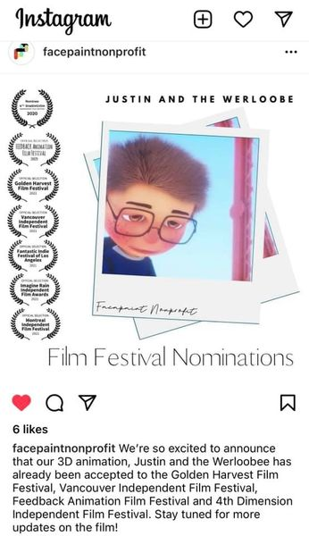

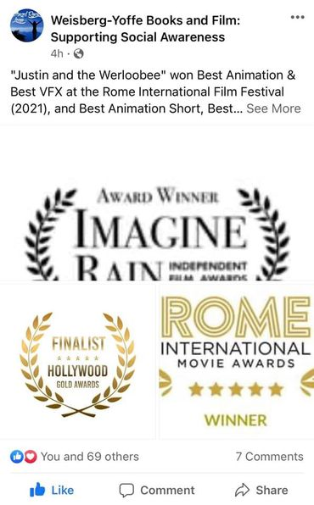

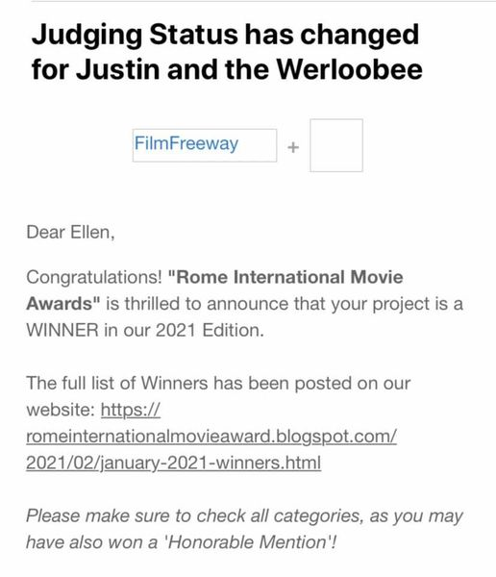

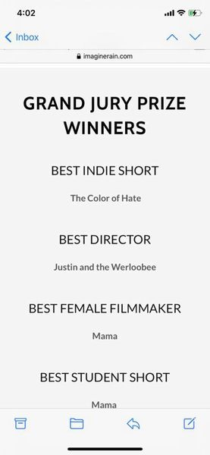

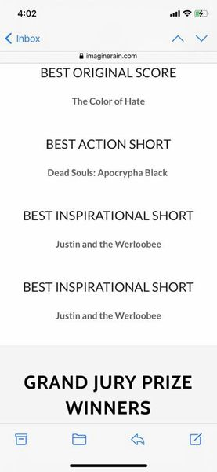
+4

11
4 Comments
Like
Comment

Lisa Smith | 6:25 PM (2 hours ago)
to me

Hi Ellen,

Thank you so much for sharing this fabulous video!! It is terrific! I can relate as I was bullied pretty bad in middle school. It is a great message about how kindness to others is the greatest gift we can give ourselves. Love it!! Good luck with it at the festivals.

The snow was not too bad here. The worst part of it was taking out our mini dachshunds during and just after it. The second storm was not much at all. Maybe an inch or two.

Thanks, again, for sharing with me. I will be sure to keep it to myself.

xoxo L
Victor Gold | 2:16 PM (6 hours ago)
to me

Yo Ellen,
Congratulations on being selected by the Rome International Movie Awards as a winner of superior animation films. You and Ken deserve all the acknowledgement that you are receiving. Aimee and I are thrilled for you. We are both amazed at your creative abilities. Many blessings to you and your dynamic family. You have set the bar quite high. You help to male the world a better place. Justin and Werloobee must be very proud.

Peace,
VG
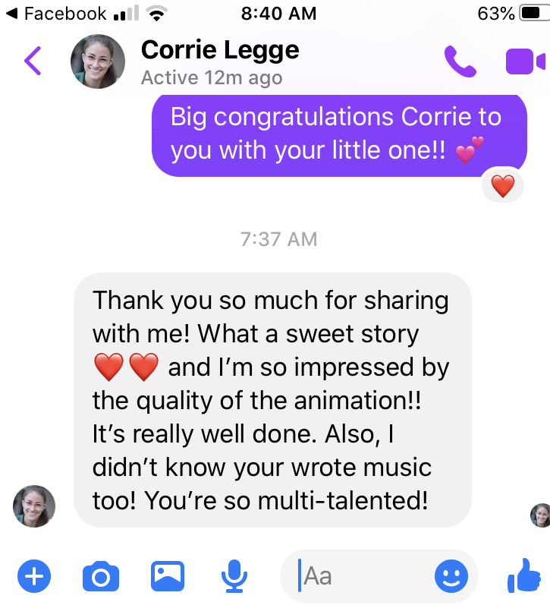

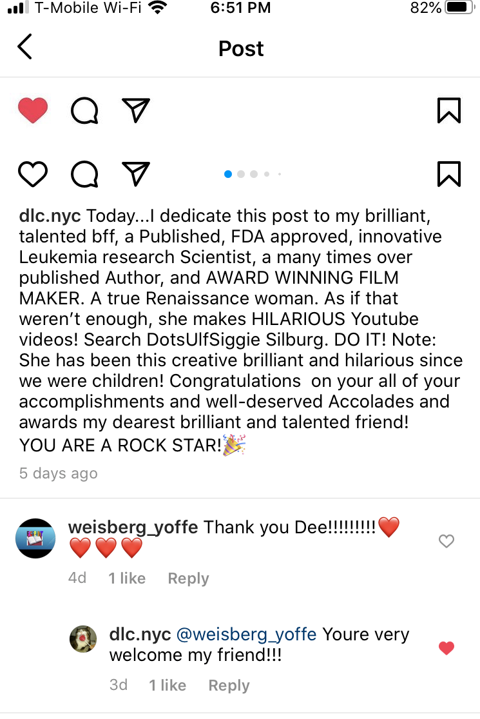

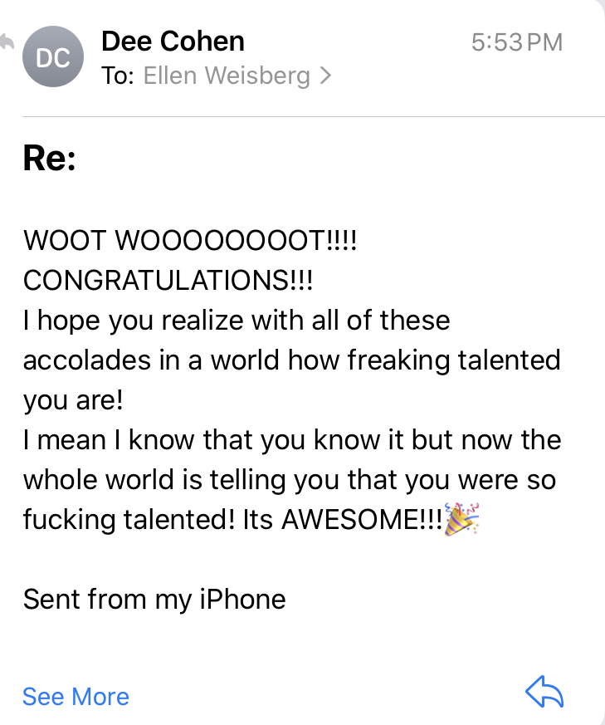

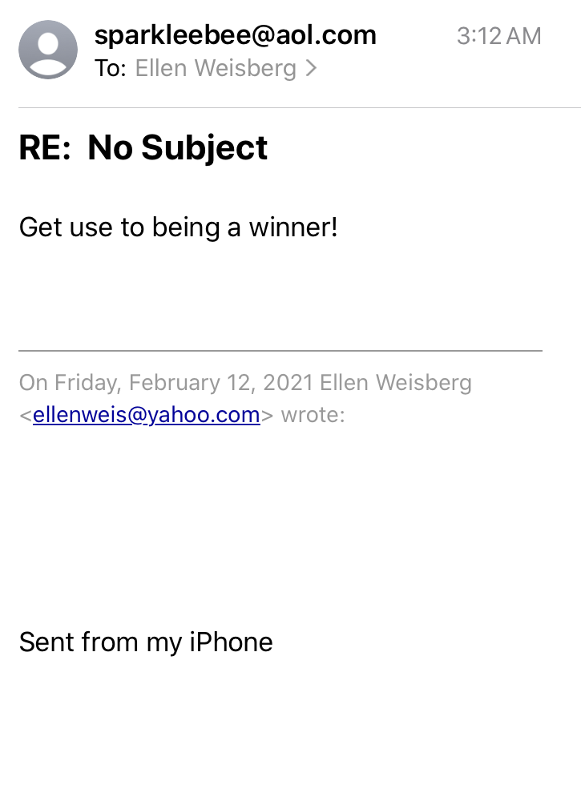

Re: Justin and the Werloobee
Feb 27 at 3:36 PM
PrintRaw message

Renee Wright-Michaud <oceansedge2@hotmail.com>
To: Ellen Weisberg <ellenweis@yahoo.com>
Aw, Ellen!! Such a sweet movie! I LOVED IT! Brought a tear to my eye. I can see why it is winning so many awards - it is a great story!
It's so nice that you saw your vision through of writing the story and then bringing it to life with the 3D animation. Great job!
I hope it was a fun journey creating it. Thanks, again, for sharing with me!

leona palmer | 6:04 PM (1 hour ago)
to me

Wow! Congrats for your accomplishment and the honor you received as a result of Fruit of the Vine! You must be flying high! ! ! (Can I help to scrape you off the ceiling?) I am so proud to have a friend who has made so many wonderful accomplishments.

Thanks for sharing -- I truly agree with all of the audience responses -- and I really loved your video the first time I watched it and all the times I've watched it since.

Yay - Ellen and Ken ! ! !

Love and Hugs,
Lee
Rosalie Nesbit | Thu, Mar 11, 10:19 PM (9 hours ago)
to me

Lovely!
Everyone had something different they appreciated - some things I
hadn't considered. That say your work has depth and beauty.
Well done, kiddo! :-)
Rosalie

Renee Wright-Michaud <OceansEdge2@hotmail.com> | Mon, Jan 18, 6:05 PM
to me

Oh, how exciting, Ellen! I'm telling you - maybe you will win an OSCAR!!!
Thanks for sharing, I am so excited for you. Fingers crossed!
Renee Wright-Michaud | Thu, Mar 11, 12:19 PM (19 hours ago)
to me

That's awesome, Ellen! I LOVED hearing that feedback after the people saw the film. I bet you loved it, too!
Thanks for sharing...made me smile today.

Victor Gold | Mar 12, 2021, 7:16 PM (14 hours ago)
to me

Yo Ellen,
Congrats on the fabulous reviews your animation film is getting. It sounds like this is just the beginning in terms of the film's exposure. To get such positive reviews much be very reassuring. Who knows, you might become the Walt Disney of this generation. Who knew I would have such a awesomely talented niece? Very cool! Keep me posted.

Peace,
VG

ReplyForward

cult movies festival <cultmoviesinternational@gmail.com>
To: Ellen Weisberg <ellenweis@yahoo.com>
Always
Best regards
Cult Movies International Film Festival

On Mar 28, 2021, at 3:44 AM, Ellen Weisberg <ellenweis@yahoo.com> wrote:

Thank you! 😊
Sent from my iPhone

On Mar 27, 2021, at 7:09 PM, cult movies festival <cultmoviesinternational@gmail.com> wrote:

Hello dear
Thank you for sharing your movie with us
I believe it is an amazing animation
Best regards
Cult Movies International Film Festival

Poorvu, Philip D.,M.D.
Tue 4/27/2021 6:16 AM





To:
- Weisberg, Ellen Lori
Thanks Ellen! Thanks so much for sharing the film with me. Loved it! Great job and congrats!
Phil

WL

Weisberg, Ellen Lori
Mon 4/26/2021 8:33 PM
Hi, Phil, Just wanted to let you know how much I appreciate your being there for my mother and letting me know what you thought of her CT scans. Also, I don't think I told you, but Ken and I took some of the royalty money for midostaurin and put it toward a

Re: Justin and the Werloobee link
May 2 at 5:54 PM
PrintRaw message

Aliya Swei <aswei@beacondentalhealth.com>
To: Ellen Weisberg <ellenweis@yahoo.com>
You did an amazing job! I hope it only gets more and more recognized!!
- Aliya

Cosmic Film Festival <cosmicfilmfestinfo@gmail.com>
To: Ellen Weisberg <ellenweis@yahoo.com>
Hi Ellen,
Thank you for your submission! That sounds like a wonderful backstory to your film. We are looking forward to reviewing it.
Janani Vaidyanathan
Online Festival Manager
https://www.cosmicfilmfest.com/

Re: Submission of "Justin and the Werloobee" to the Krimson Horyzon International Film Festival
May 11 at 12:29 PM
PrintRaw message

Krimson Horyzon IFF <krimsonhoryzoniff21@gmail.com>
To: Ellen Weisberg <ellenweis@yahoo.com>
Hi Ellen,

Woow, this is very different and we all would like to watch your film.

Re: Submission of "Justin and the Werloobee" to Satisfied Eye International Film Festival
May 14 at 5:28 PM
PrintRaw message

Artistic Director <hello@satisfiedeye.com>
To: Ellen Weisberg <ellenweis@yahoo.com>
Thank you Ellen, I look forward to passing Justin and the Werloobee to our judging panel, it's a subject close to my heart; and I hope to see your film at our festival.

Kind regards,

Chris Hastings

Writer | Director | BAFTA | Emmy

CEO, 1066 Productions
Follow 1066 on Twitter http://twitter.com/1066Live
Artistic Director, Satisfied Eye International Film Festival
www.satisfiedeye.com
www.filmfreeway.com/seiff
Dear Ellen,
End of Days Film Festival has posted a response to your review.
Thank you Ellen. We enjoyed your film "Justin and the Werloobee". We are excited to have you as an official nomination in the animation category. Great work!

Dear Ellen,
Director!
I write to you with great respect and pride and want to congratulate you now! I am infinitely happy that you sent your work to my film festival! So the summing up has come. Our whole team congratulates you on your result! Your creativity is excellent! We got great pleasure looking at your picture! Thank you!
Congratulations !!!
You can see all the results on the website and soon we will post them on the social network!
Also you can order your statuette, simply submit your work again to category 'Trophy' and add in cover letter all the information about the address.
Good luckYou can download laurel from here: https://filmfreeway.com/laurels/59074/ADIFF-1
Justin and the Werloobee

Honorable Mention
Project has been selected as an honorable mention in festival.

You can contact ADIFF - Actor&Director Awards by replying to this email or sending an email to adiff.official@yandex.ru.

Re: Submission of Justin and the Werloobee to Filmhaus Berlin International Film Festival
Jun 1 at 1:06 PM
PrintRaw message

Jasper Lorenz <info@filmhaus.org>
To: Ellen Weisberg <ellenweis@yahoo.com>
Thank you for competing Dr. Weisberg and supporting our cool little Berlin fest!
The film is fantastic, we are working on it today!
Willkommen in Berlin!!
Results are just around the corner!

Hi Ellen,
Thanks for submitting your beautiful project to Madrid ARTHouse Film Festival. We have carefully evaluated the submitted projects and are very happy to inform you that we have updated your status of the project to semifinalist. This means that your project is now considered for an award for this month. At this stage, our judges will privately review your work and will let us know the name of the winners by June 15.
Please consider that this is an online festival, and we don't need any materials from you at this stage. If you go to the next stage, your project "might" be considered for our annual online event. If that happens, we will be in touch with you later. We sincerely appreciate your patience till then. We will be in touch with you once we know the results.

We don't issue a customized certificate for the semifinalist projects. This service is reserved for our winners. If you like to share this success with your colleagues, friends and the loved ones, please use this generic laurel:
https://filmfreeway.com/laurels/59856/MadridArthouseFilmFestival

It was a pleasure to have your film at our festival. Don't hesitate to get in touch with us if you have any questions or concerns.

Cheers,
Madrid Arthouse Film Festival
Dear Ellen,
We have some good news for you! Justin and the Werloobee has been selected at Robinson Film Awards. Congratulations, your project was one of the best!

Click here to download your winning laurel: https://filmfreeway.com/laurels/60067/RobinsonFilmAwardsInternationalFilmFestival

Feel free to submit a review on our Film Festival, we will be very grateful: https://filmfreeway.com/RobinsonFilmAwardsInternationalFilmFestival

Thank you very much for your application. Welcome to RFA family!

RFA official webpage: https://robinsonfilmawards.wixsite.com/home
Instagram: https://www.instagram.com/robinsonfilmawards/
Twitter: https://twitter.com/RobinsonAwards
Facebook: https://www.facebook.com/robinsonfilmawards

Good Luck & All The Best!
RFA Team
Black Board International Film Festival <info@blackboardforum.in> | 6:42 AM (1 hour ago)
to me

Hello,

Congratulations!, your film "Justin and the Werloobee" has been officially selected for Blackboard International Film Festival.

We really enjoyed your work. From all the films that have been submitted, we have selected some set of films and we will be screening all the films that are Officially Selected. From the officially selected films, we will be selecting the best of films that are been submitted and that will be announced very soon.

We are much more interested in Physical Screening. But due to the surge in Covid cases in India, we are supposed to postpone the date of the Screening session. Once things get normal we will announce the date of physical screening at Elambachi-India.

We request you to send us the following files for the physical screening process.

1. Online screener of your film (Google Drive, Youtube, or Vimeo link) with English subtitles. Please provide the password if applicable.
2. Trailer of your film.
3. 2 Frames of your film.
4. 1 Official Poster.

We have attached Laurel with the mail. If you have any queries kindly mail us info@blackboardforum.in and we are happy to help you out.

Congratulations again!
Stay safe, stay well!

Best Wishes,
Regards,
Blackboard International Film Festival
https://blackboardforum.in
info@blackboardforum.in
Elambachi(Payyanur-Kerala), India
Dear Ellen,
Congratulations!
Justin and the Werloobee has been officially selected for the bi-monthly Pinnacle Film Awards May - June Online Competition.
Below is a summary for each category that was judged.
Directing: Did the Director successfully execute the overall vision of the Animation by making sure it is being realized to the fullest extent at every moment? 4 of 4 say yes.

Writing: Did the project have a strong structural viewpoint and a good plot that tells both an intriguing and unusual story? 4 of 4 say yes.

Editing: Did the Editor create a visual rhythm in the project that fulfills the vision of the project? 4 of 4 say yes.

Voice Actors: Did the Voice Actor/s convince the audience they are the characters they're portraying, and consistent with the goal of the project? 4 of 4 say yes.

Score / Sound Design: Did the Film Score / Sound Design compliment the visuals, and also help convey the emotion of each scene? 4 of 4 say yes.

Your project has been nominated for:
Animation Short

Rita Bekqeli <rita@dokufest.com> | Mon, Jun 28, 3:22 PM (1 day ago)
to me, Idriz, Zana

Dear Ellen,

Hope you are doing well.
Thanks for submitting your film “Justin and the Werloobee” to Dokufest 2021.

We have watched all the submissions, but due to unknown times we didn't know what and how we are doing the festival for that reason we were a bit late with decisions.

Finally, we have decided to go on physical version and continue with our plans.

I'm writing to you regarding your film "Justin and the Werloobee" that we found it quite suitable for our kid’s section called "DokuKids" and wanted to ask if we can include it in this program?

The Dokukids program is a noncompetitive section dedicated for kids up to 12 years and is free of charge.

We would very much appreciate it if you can allow us to screen your film and send us a screening copy in h264 or Prores format before 15th of July.

Please reply to us for positive or negative answer in order to know and continue with scheduling the screening!

Thanks in advance and support!
Rita Bekqeli
(Dokufest is BAFTA-qualifying)

Re: Your Film Submission and the 2021 Flickers' Rhode Island International Film Festival
Jul 26 at 5:52 PM
PrintRaw message

George T. Marshall <flicksarts@gmail.com>
To: Ellen Weisberg <ellenweis@yahoo.com>
Cc: Shawn Quirk <quirk220@gmail.com>
2 Files703.4kBDownload All

Preview
PNG302kB

SEMI-FINALIST-FlickersRhodeIslandInternationalFilmFestival-2021.png

Download

Preview
PNG401kB

SEMI-FINALIST-FlickersRhodeIslandInternationalFilmFestival-2021X.png

Download

Hi Ellen and Ken.

We loved "Justin and the Werloobee." Thank you for sharing your creativity and art with us.
Re. laurels, you should be able to access them now on FilmFreeway.

Here is this link:
Direct laurel recipients to this link to download images:
https://filmfreeway.com/laurels/45750/RIFilmFest
Tip: Include this link in your Submitter Notifications.

The password is FilmFest

In case you have issues, I've created them for you (in FilmFreeway, you can change fonts, etc.)

Take good care.

George

Dear Ellen,
I am very sorry to report that your film entry has not been selected for this year's Flickers' Rhode Island International Film Festival in August. For RIIFF 2021, we received just over 6,500 entries submitted for consideration, making for a truly daunting adjudication process. We received such amazing films, making the competition lively, exciting, and extremely difficult. Our judges indicated that 985 films scored high enough to be included in this year's festival; unfortunately, this is something impossible to do with a six-day schedule. Ultimately, we were able to program approximately 400 titles this year, placing many films at the last minute as we found additional screening slots. I should note that this is the largest number of entries we have ever screened in what will be a hybrid Festival with over 100 being World, North American and US Premieres.

Despite our final decision, we try our best to make sure great work and talented filmmaking do not go unnoticed, which is why we have listed your project as one of this year's Semi-Finalists for the 2021 Flickers' Rhode Island International Film Festival.
Your film was highly rated by our judges, and made it past our first round of adjudications towards acceptance. While your film will not be featured as part of this year's Official Program at RIIFF 2021, it will be considered for future programming initiatives throughout the coming year. Whether it is part of our Roving Eye International Film Festival, our weekly television show "doubleFEATURE," or part of our annual Vortex Sci-Fi Fantasy and Horror Film Festival, there are a number of festival screenings and events we produce for which your film will be considered in the months to come.

While we do not provide laurels specifically for our Semi-Finalist filmmakers, you are more than welcome to use the laurels provided by Film Freeway if you wish to promote your film's Semi-Finalist status.
As a filmmaker myself, I know how much time and effort it is to make a film one can be proud of. So, I want to take this time to congratulate you on your fine work. Your film has struck a chord with all of us here at Flickers, and I wish you all the best with your work in the months and years to come.

Thank you for sharing your creativity with us. It was a privilege viewing your film.
Warm Regards,
Shawn Quirk
Program Director
Flickers' Rhode Island International Film Festival

Dear Ellen,
Oakville Film Festival 8th Edition has posted a response to your review.

Thanks Ellen for bringing Justin and the Werloobee
to the festival! Marvellous film. So glad you could join us and
hope you come back again with your next film.

jeff@one-reeler.net
Fri, Aug 6, 9:59 AM (2 days ago)

to me

Hello Ellen,
My apologies for this slow acknowledgment!
The pleasure is all ours! We really enjoyed JUSTIN AND THE WERLOOBEE and are proud to include it among our Winners.
Thank you, Ellen, and congratulations once more!!
Sincerely,
Jeff Hudgins
Organizer
One-Reeler Short Film Competition
m: +1 323 844 3918
a: Los Angeles, CA | USA
w: www.one-reeler.net e: jeff@one-reeler.net

12 categories, 12 minutes or less!

Hi Ken and Ellen,
Thanks - I’ve now downloaded this and I have (hopefully) just enabled the download function so you can download the teaser?
https://vimeo.com/570982807
Justin and the Werloobee plays very much to our sensibilities – many of our team have children and we are all keen to inspire the younger generation (and also encourage them to be creative also).
Would you be interested in taking part in a Q&A after the block has played?
Best wishes,
Andy…

Bettiah International Film Festival <biff2020india@gmail.com> | Aug 24, 2021, 11:35 PM (3 days ago)
to me

Dear filmmaker,
I saw your project at Gully International Film Festival. I am chief Jury there. It's really beautiful film. We appreciate your work and respect your vision. Here we are for you with another Grand International Film Festival of India ie Bettiah International Film Festival 2nd Season. Stage is ready. You can also submit your beautiful project here.

Submit your Films here

FILMFREEWAY :- https://filmfreeway.com/BettiahInternationalFilmFestival

Thanking you.

Regards,
Richa Sharma
BIFF

Dear Ellen,
Holidays365 International Film Festival™ has posted a response to your review.
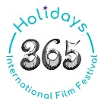 It was a real pleasure watching your film! Thanks for sharing it and its impactful message with our viewers.
Dear Ellen,
THE GALACTIC IMAGINARIUM FILM FESTIVAL ( Sci-Fi & Fantasy) has posted a response to your review.
Thank you! Your film was greatly appreciated by the jury! We hope to have you back at our future editions!

Dear Ellen,
Luminous Frames has posted a response to your review.
Thank you Ellen, we look forward to watching your next animation. Keep up the good work in researching the adverse consequences of bullying on children's life.

